**Introduction**

In the month of May 2021, I applied for the internship position at The Sparks Foundation for the position of ‘Web Development and Designing intern’. During the end of June 2021, I received my selection certificate and on 1st July 2021 I got the problem statement. My start date of internship was on 1st July 2021 and it ended on 1st August 2021.

The problem statement was to create a Bank web application. The detailed problem statement from the organization I have given after the Introduction section.

Due to the digitalization in the today's society and the upliftment of it now the finance sector is also moving towards a digital era

Unlike earlier time where all the banking related transactions which bird taking place in the offline mode now those same transaction can be done digitally very easily from anywhere through a stable internet connection

There are different modes of transferring money from one account to others

For example, debit cards or credit cards which are directly connected to one of the bank accounts of the user

These cards have allowed the user to easily perform financial transactions from anywhere in the world

The other most important digital transaction mode is through NEFT, RTGS and IMPS

In spite of the complete digitalization in the finance sector today also many of the people in the urban area and rural area who are not comfortable with this digital mode does offline transactions

For example, if they want to transfer money to any other recipient then they just do this by depositing a cheque in the bank

They simply draw a stating payee as their name along with the account number where they want to transfer the money along with the proper hand signature

But these people would perform offline transactions they also do perform online transactions sometimes

Whether they perform online transaction or off introduction respectively the money in the account must be updated irrespective of any transactions they do

If they perform online transaction then obviously since the credit card or debit card or NEFT/RTGS/IMPS are directly linked to the bank account and so whenever any online transaction is performed the money in the account it is automatically updated

But have the same user performs any offline transaction like depositing any check or withdrawing money from his or her account then the money wouldn't be auto updated in the account which should not be the case

Now since to perform any offline transaction the user himself needs to come to the bank so as soon as user performs and your current transaction at Bank immediately the money in his account has been updated and they’re by any employee or the manager at the respective bank

So, in this internship I have created a web portal for all those managers for the bank employees who needs to update the respective bank accounts show that in future if the user performs any online transaction, then the money would be updated

First of all, if any user opens a bank account at our bank the employee the manager must register that particular user in to our portal by providing the username his or her email ID and the minimum balance

Here I have kept the user’s name as the primary key or unique

Now if any user performs any offline transaction let say if he deposits check which has the sender account number beneficiary account number and transacted amount, then immediately the concerned employee for the manager would first enter that particular user name and enter into his account. There would be a transfer button where by clicking it the manager should enter the beneficiary account number and the money to be transferred from the cheque slip

And after clicking transfer button then give money values in their respective accounts would be updated

Here I have given the privileged for the manager to view sender and the beneficiary’s transaction history

In this portal the manager can view all the customers who have their bank accounts at our bank

I have given all the validations in the portal like a user with the same already existing name cannot get registered himself

I've also given validation where if the transaction amount is greater than sender account then the system will throw a proper error

**Problem Statement: -**

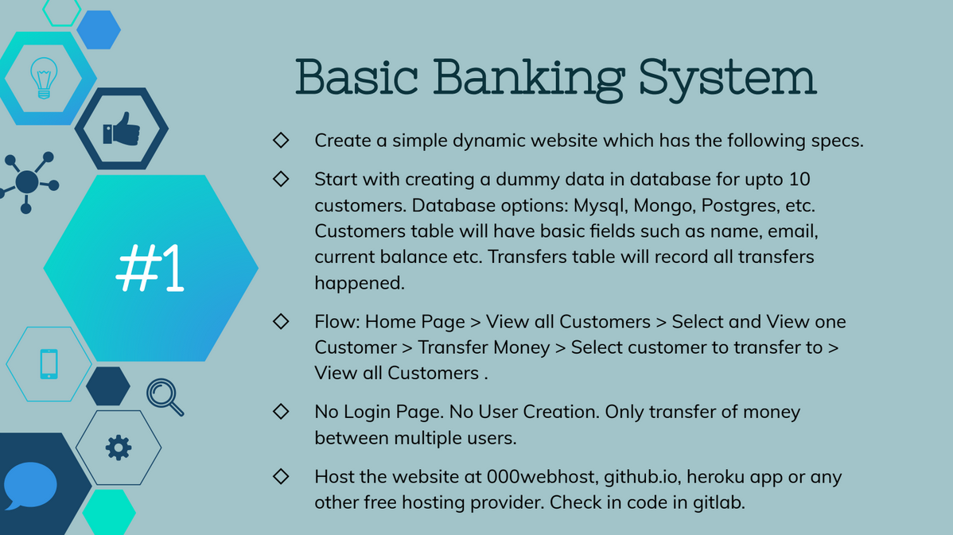

**Basic Banking System**

Create a simple dynamic website which has the following specs.

Start with creating a dummy data in database for up to 10 customers. Database options: MySQL, Mongo, Postgres, etc.

Customers table will have basic fields such as name, email, current balance etc. Transfers table will record all transfers happened.

Flow: Home Page > View all Customers > Select and View one Customer > Transfer Money > Select customer to transfer to > View all Customers. No Login Page. No User Creation. Only transfer of money between multiple users.

Host the website at 000webhost, github.io, heroku app or any other free hosting provider. Check in code in gitlab.

**Additional Task: -**

LinkedIn Profile Improvement - Improve your professional profile on LinkedIn. It is MANDATORY FOR ALL.

It is mandatory that you create a recorded video of your task and post it on LinkedIn

Peer-evaluation (mandatory for all): Watch and comment on the at least 5 task videos on LinkedIn posted by fellow interns.

It is also mandatory that your post on LinkedIn should get a min of 5 comments

**Timeline: -**

In the month of May 2021, I applied for the internship position at The Sparks Foundation for the position of ‘Web Development and Designing intern’. During the end of June 2021, I received my selection certificate and on 1st July 2021 I got the problem statement. My start date of internship was on 1st July 2021 and it ended on 1st August 2021.

After I completed my work/project and after doing all the LinkedIn additional tasks, I submitted my task through the Task Submission form and after completing my internship on 1st August 2021, I received my final Completion certificate on 5th August 2021.

**Tech Stack Used: -**

**Frontend: -**

HTML5

CSS3

JavaScript

jQuery

**Backend: -**

PHP

**Database: -**

MySQL

**Code/Text Editor: -**

Sublime Text 3

**Server and DB: -**

**XAMPP –**

 **X stand for all Operating System – platform independent**

**A stand for Apache HTTP Server**

**M stand for Maria DB**

**P stand for PHP (XAMPP written in PHP) and**

**P stand for Perl (XAMPP written in Perl)**

**HTML5: -**

* HTML an acronym for Hyper Text Markup Language
* HTML is considered a markup language for creating static web pages
* HTML defines the entire structure of a Web page
* HTML elements communicates with the browser and shows it what content and where to display
* An HTML element is defined by a start tag, some content, and an end tag:

The web browsers like Edge, Safari, Opera, Chrome, Firefox reads the HTML documents and displays them.

All HTML elements can have attributes which provides some more details about elements

Attributes are mostly specified in the start tag. All the attributes are specified with a value.

HTML defines the structures of the entire web page i.e., which element must be present at which position and all. It basically places all the html elements at different positions of the web page.

In my project I used a number of HTML elements like: -

<h1>..<h6>, <p>, <img>, <div>, <span>, <table>, <a>, etc.

But HTML doesn’t include any styling portion, which may give any styles to the HTML elements nor it includes any responsiveness nor it contains any feature which may do some calculations or any validations

But HTML5 provides a facility to provide inline CSS using the style attribute

**CSS3: -**

CSS tells the browser in which way to style an HTML document.

CSS defines the styling portion for each element of the HTML element

CSS stands for Cascading Style Sheets

CSS saves a lot of work.

External stylesheets are stored in external CSS files and the link of that file can be provided in the HTML doc

The selector generally points to the HTML element that needs to be styled.

The declaration block can have more than one declaration separated by semicolons.

A declaration contains a CSS property name and a value, associated with it.

Multiple declarations can be declared which are separated by semicolon and all are enclosed in a curly braces

In my project I used various types of CSS stylings like font colors, background colors and images, font-sizes and font-styles, borders, paddings, margins, outlines, Icons, lists, tables, display, visibility, Opacity, etc.

**JavaScript****: -**

JavaScript is considered the world's most used programming language in the web field

JavaScript defines the behaviour of different html elements of the web pages

JavaScript generally runs on the browser for any device type like mobile, tablet, laptop, desktop, etc

JavaScript can dynamically change the HTML Content. Using getElementById(), getElementByClassName(), getElementByTagName(),… the developer can easily access any html element and can give some behaviour to it

JavaScript can dynamically change HTML Attribute Values

JavaScript can dynamically change HTML styles using style property

JavaScript can dynamically show or hide HTML styles using visible property

In HTML, JavaScript code is placed between <script> and </script> tags

A JavaScript function is a block code, which is executed when an event occurs

In my internship project I used JavaScript for dynamically change the HTML attribute values, change the HTML styles, display or hide the division blocks when any specific button is clicked

I used JavaScript mainly to define the functions which tells the browser when to do what

**jQuery: -**

jQuery is a JavaScript Library which greatly simplifies JavaScript programming.

jQuery is a lightweight JavaScript library.

The main concern of jQuery is to make it much easier to use JavaScript on web pages.

jQuery takes a lot of common tasks that require many lines of JavaScript code to accomplish, and wraps them into methods that you can call with a single line of code.

jQuery also simplifies a lot of the complicated things from JavaScript, like AJAX calls and DOM manipulation.

The jQuery library contains the following features:

* HTML/DOM manipulation
* CSS manipulation
* HTML event methods
* Effects and animations
* AJAX
* Utilities

I used jQuery mainly for the widgets provided by it: -

**Autocomplete**: -

The Autocomplete widgets provides suggestions while you type into the field.

I have put this widget when the manager enters into the bank account of any user.

I have declared an array which contains all the registered usernames. So whenever the manager enters the username as per the alphabets been typed in the input box, accordingly suggestions are been given in the suggestion box

**Message Box: -**

The basic dialog window is an overlay positioned within the viewport and is protected from page content (like select elements) shining through with an iframe. It has a title bar and a content area, and can be moved, resized and closed with the 'x' icon by default.

**PHP: -**

****PHP is a server-side scripting language, used for making dynamic and interactive Web pages. PHP plays a major rolw for connecting MySQL DB to HMTL web pages

PHP stands for: Hypertext Preprocessor"

It is a widely-used and an open source scripting language

PHP scripts are mean to get executed on the server

PHP files can contain text, HTML, CSS, JavaScript, and PHP code

PHP code gets executed on the server, and the result are returned to the browser as a normal HTML web page.

PHP files have extension ".php"

PHP can generate page contents having dynamic data may be from the Database

PHP can create, open, read, write, delete, and close files on the server

PHP can collect form data and send data to the MySQL DB

PHP can send and receive cookies

PHP can perform all CRUD operations in a database

The PHP superglobals $_GET and $_POST are used to collect and sent form-data.

A query is a question or a request.

We can query a database for specific information

Following is a small PHP script to make a connection with a MySQL DB

<?php  
$servername = "localhost";  
$username = "username";  
$password = "password";  
  
// Create connection  
$conn = new mysqli($servername, $username, $password);  
  
// Check connection  
if ($conn->connect_error) {  
  die("Connection failed: " . $conn->connect_error);  
}   
echo "Connected successfully";  
?>

For my project, I used PHP as a server-side scripting language where I used functions, loops, if-else statements of PHP

My main concern to use PHP was to connect my static and dynamic web pages with MySQL DB

I was able to perform various CRUD operations with the PHP and MySQL DB

To store the users information, modify the amount value while transactions, etc

**MySQL Database: -**

SQL is a language for posting, modifying and getting from database tables.

Using SQL, one can perform following operations very easily –

SQL can execute queries against a database

****SQL can retrieve data from a database

SQL can insert records in a database

SQL can update records in a database

SQL can delete records from a database

SQL can create new databases

SQL can create new tables in a database

SQL can create stored procedures in a database

SQL can create views in a database

SQL can set permissions on tables, procedures, and views

**RDBMS**

RDBMS is an acronym for Relational Database Management System.

RDBMS is the basis for SQL, and for all modern database systems such as MS SQL Server, IBM DB2, Oracle, MySQL, and Microsoft Access.

The data in RDBMS is stored in database which is called as tables. A table is a collection of related data entries and it consists of columns and rows.

**System Overview: -**

**Database: -**

**Table 1: - User table**

**User Table Structure and Schema**

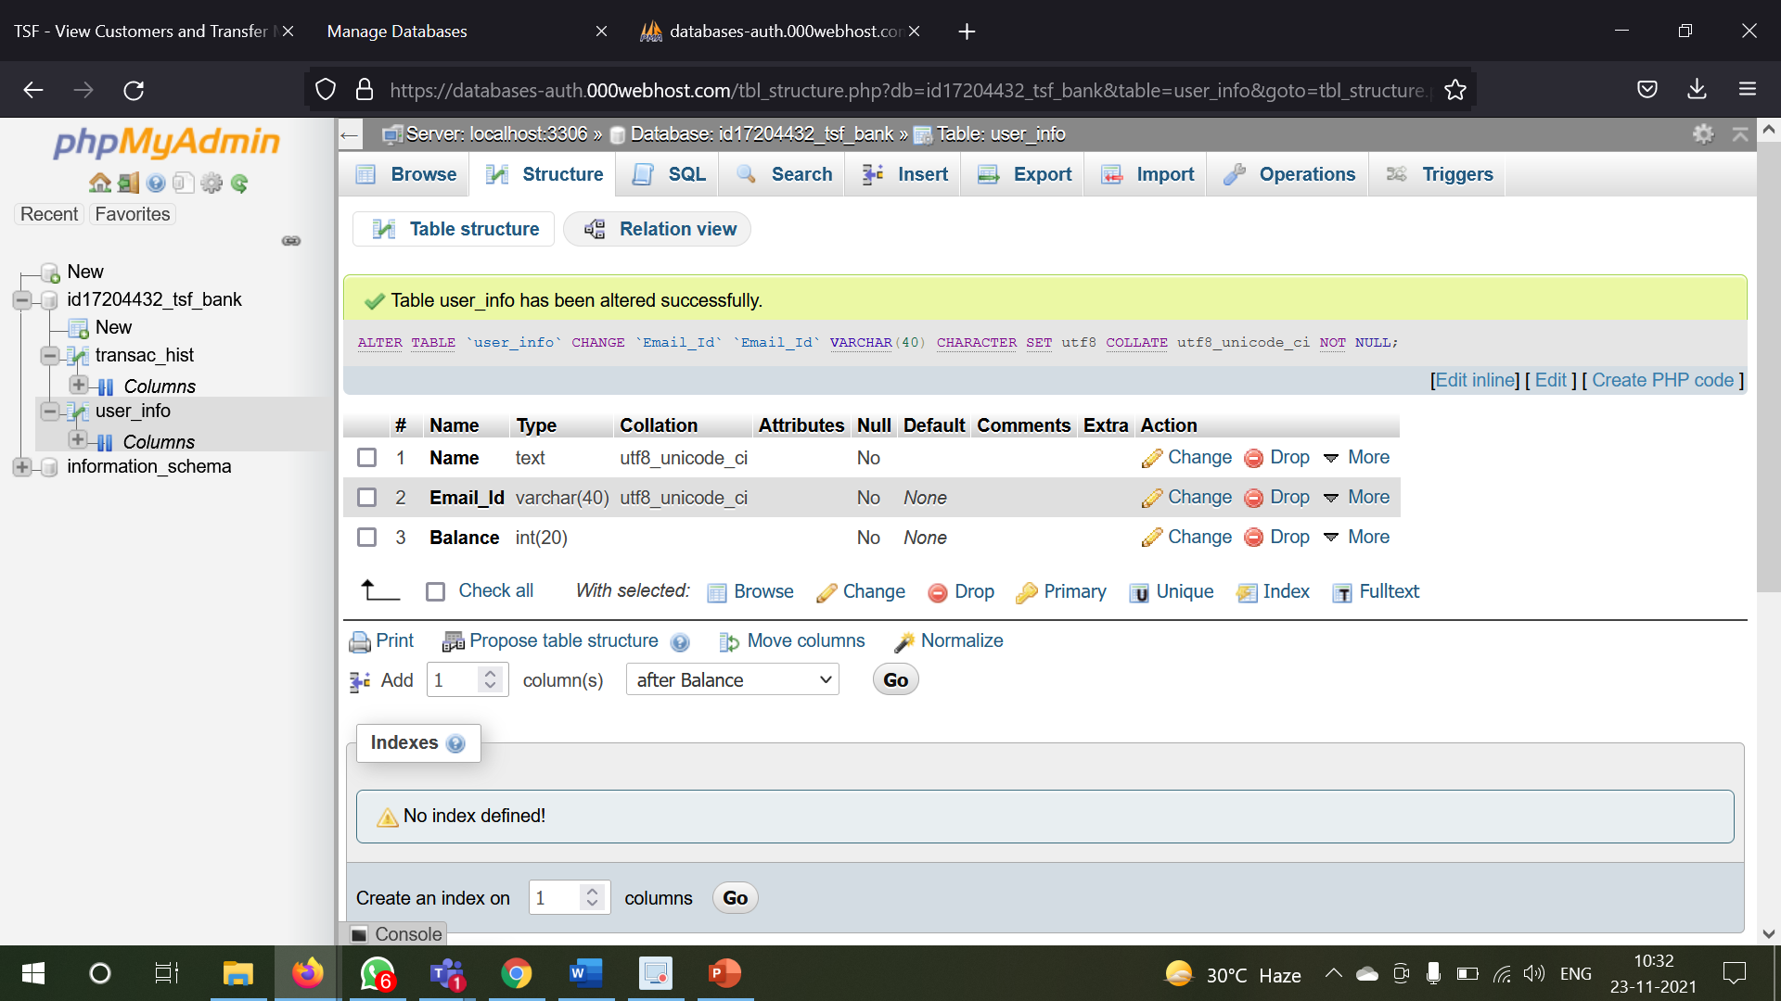

**User Table Entries: -**

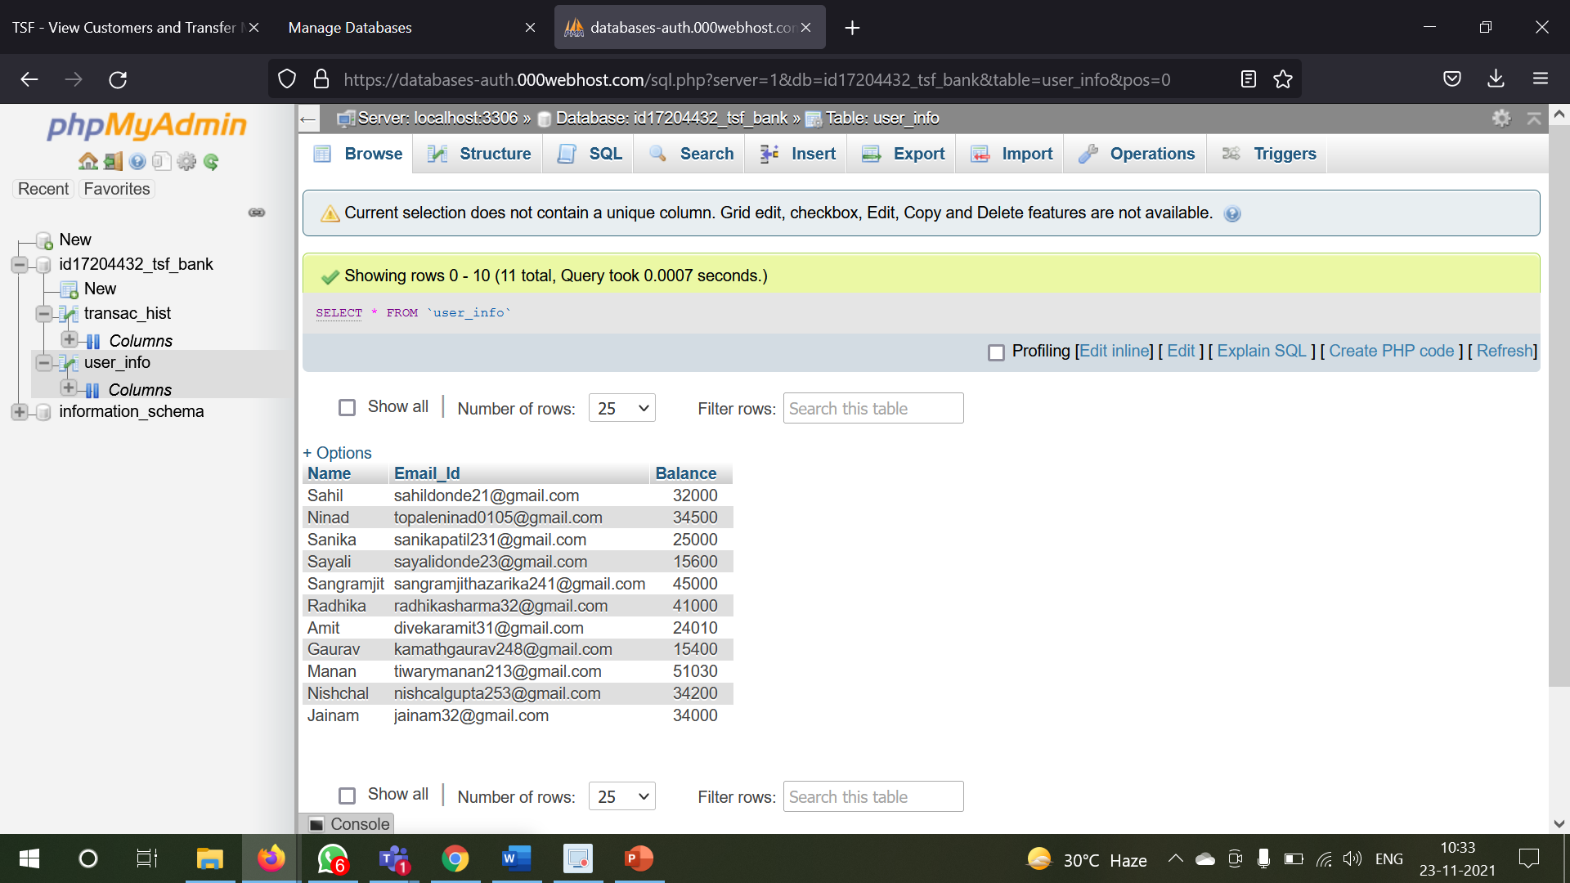

**Table 2: - Transaction Table**

**Transaction Table Structure and Schema**

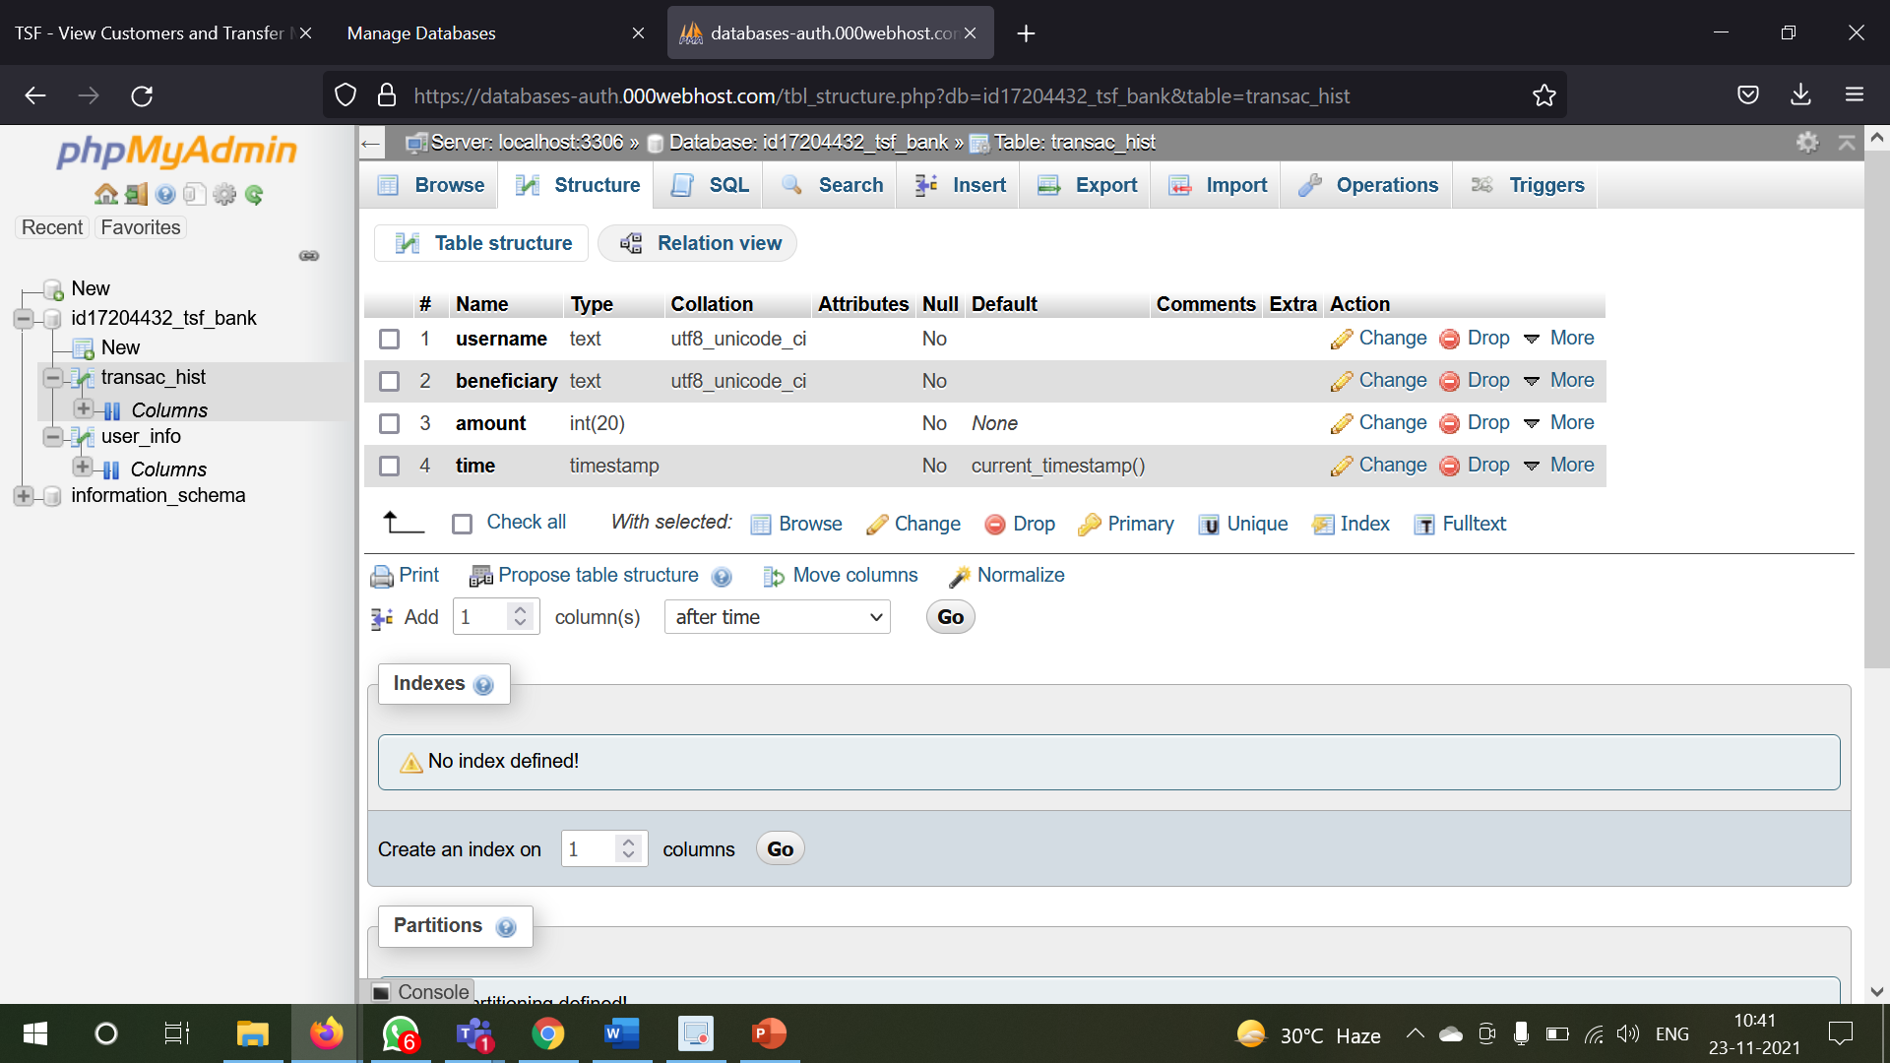

**Transaction Table Entries: -**

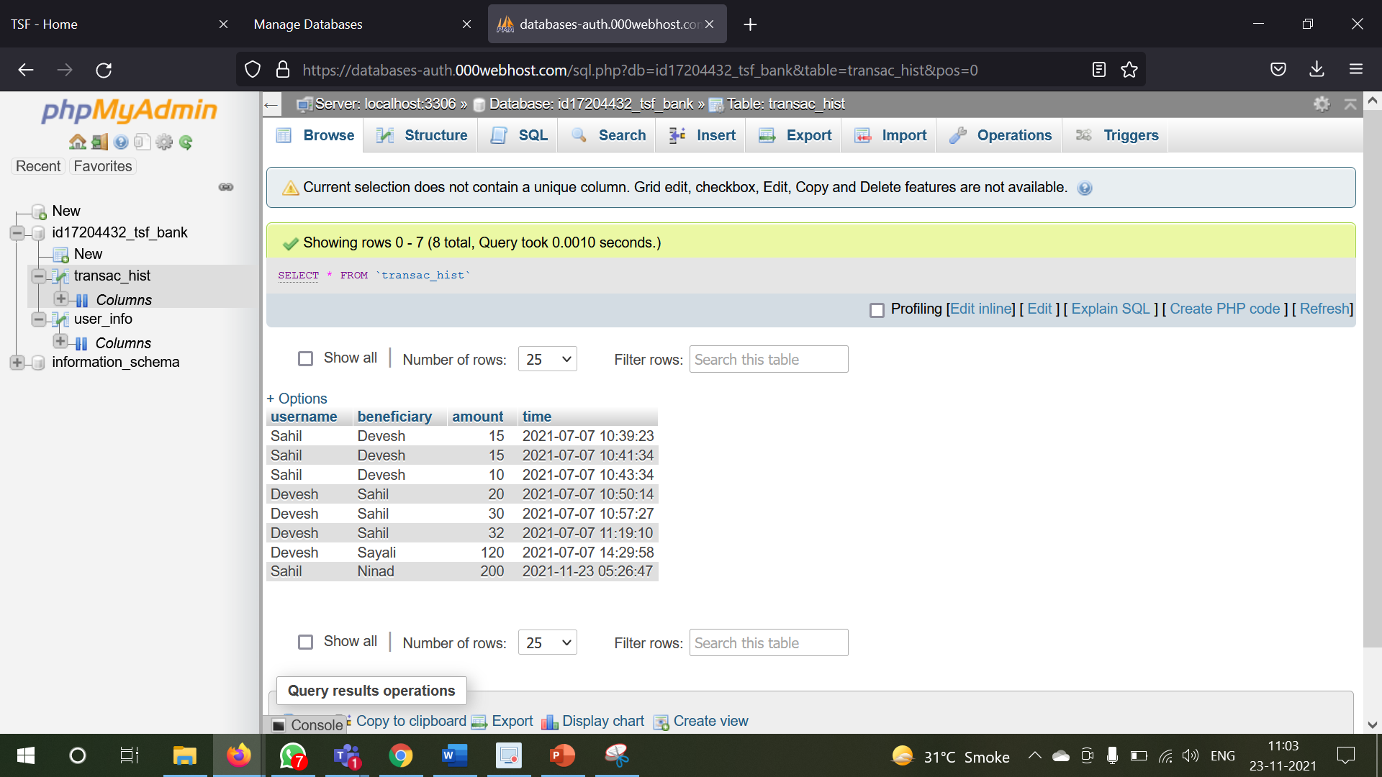

**Registration of the user: -**

As soon as any person opens a bank account in our bank then the manager would take his details like username, email ID and the minimum balance amount required to open a bank account from the user and get registered into our portal

I have given a validation that if an already person exist with a certain username in our users table of MySQL DB, then another person with that same username cannot exist

So as the manager goes on typing the username in the user input field the portal automatically notifies that whether the typed username exist in the bank portal or not from PHP and SQL queries

In many websites for this feature the user needs to enter the all details and then click submit and then the user will know whether the user exists or not

But instead to save the users time what I have done is that as the manager goes on typing the username in the user input field, I have used on-change JavaScript event where as soon as any keyboard is being pressed while typing the username and the checking functionality of the username existence or not runs where the backend PHP script checks the username existence in the Database with SQL queries and the manager is being notified

In the below picture, I am trying to type “Sahil” as the username which already exists in the users table. Till I type “Sahi” the system tells that the username **Available**, and when I complete the name by typing ‘l’, so it becomes ‘Sahil’ which do exists and system tells **Unavailable** as ‘Sahil’ already present in the user table.

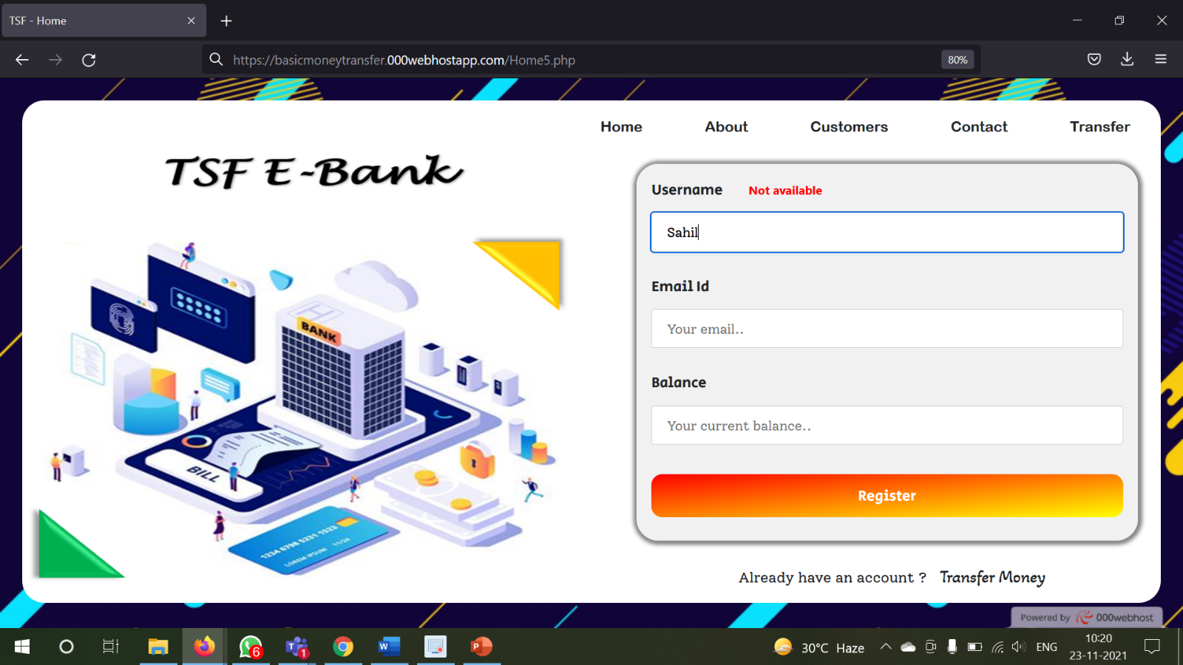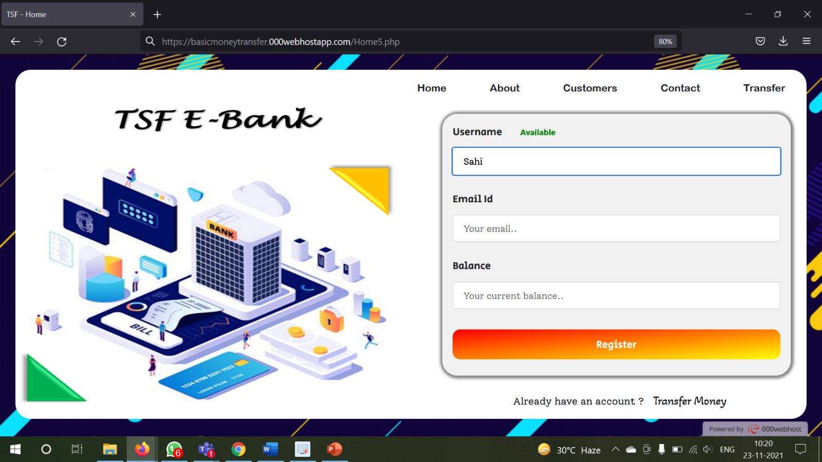



For email validation I have used the JavaScript regex functionality

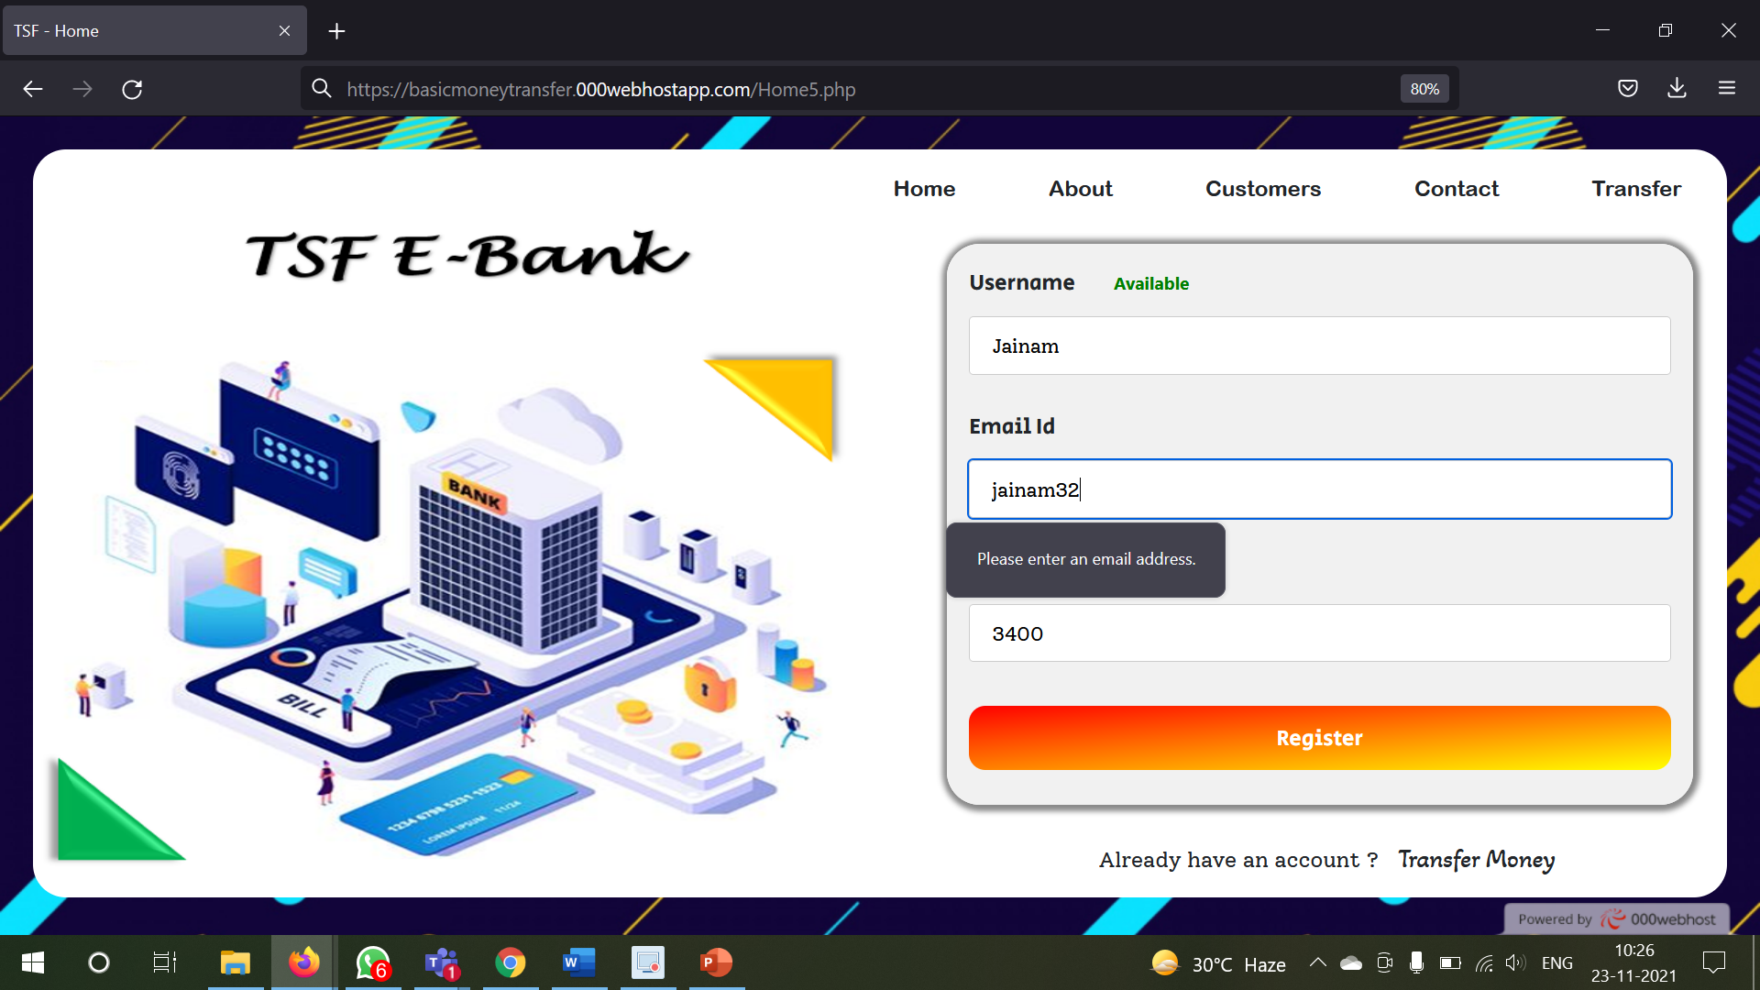

And the minimum balance amount must be greater than 2000

If all the details are fitting within the validations, then the user is been successfully registered in our portal and in the users table a row with a unique username is been inserted

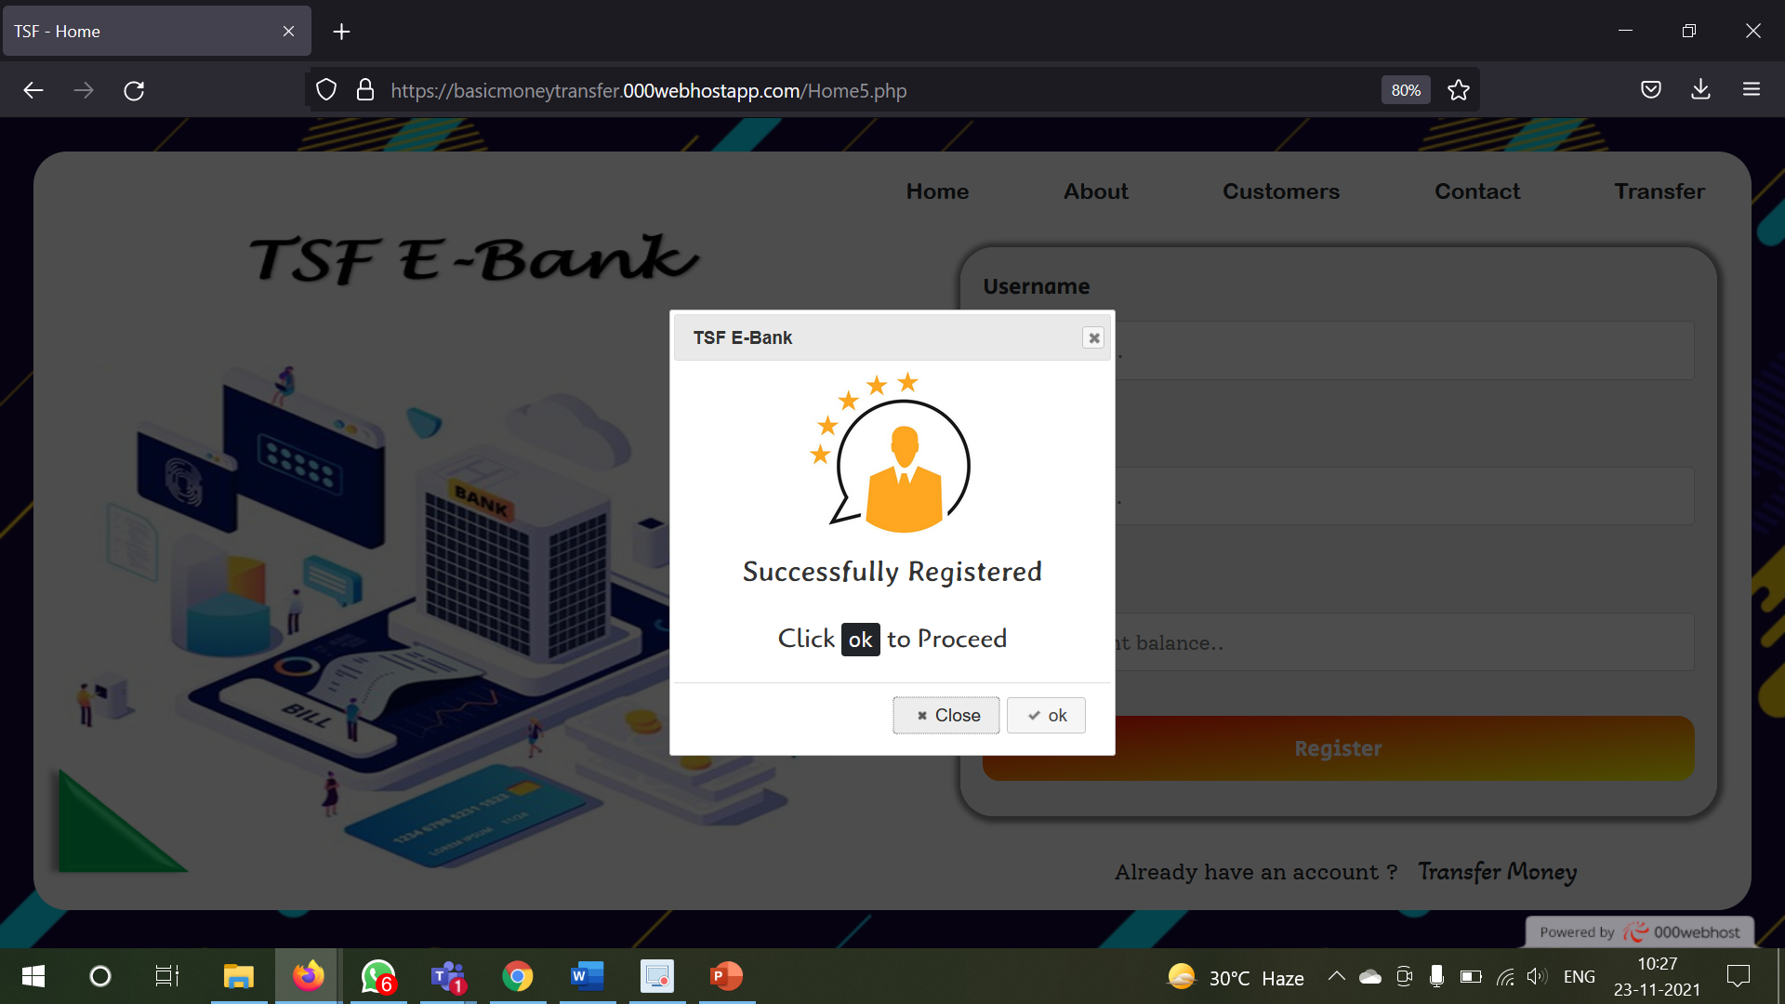

**Entering into the Senders account: -**

Now whenever any registered user comes to the bank for depositing any check then manager takes that check and opens our portal

By clicking on the transfer icon on the menu bar the page remains the same wild the registration division log is being replaced with the transfer money division block

For this I used JavaScript display and hide functionality

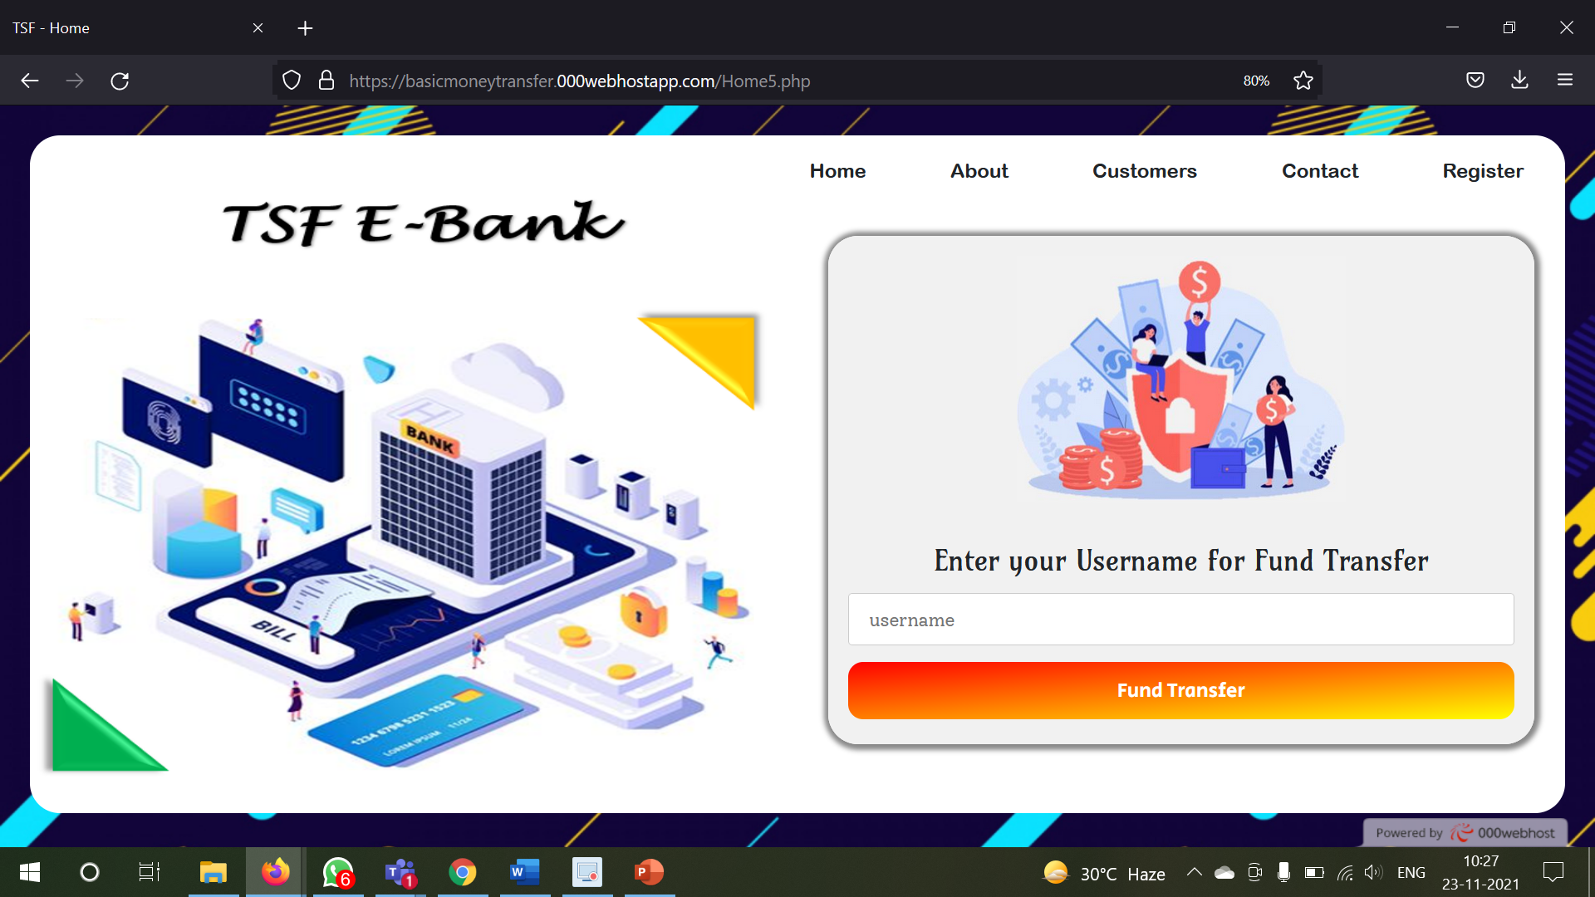

Now in the transfer money division block the manager and enters the person’s name from which the money has to be debited

Now as soon as the manager types in the sender's name in the sender's input box, due to the autocomplete feature on the check value which I have used in my project all the list of the registered user names comes in the dropdown suggestion box.

The names appearing in the dropdown suggestion box according to the alphabets typed by the manager in the sender input box

Then from the dropdown the manager and select the desired name and can enter into the sender's account. Actually, a function runs when a key is pressed on input box where all the usernames which are registered are been fetched from Users database and with the help of PHP, I stored all the names in a PHP array and converted it into a JavaScript array and passed it to the Autocomplete widget of the jQuery. And in the drop down we are able to see the list of elements in that array.

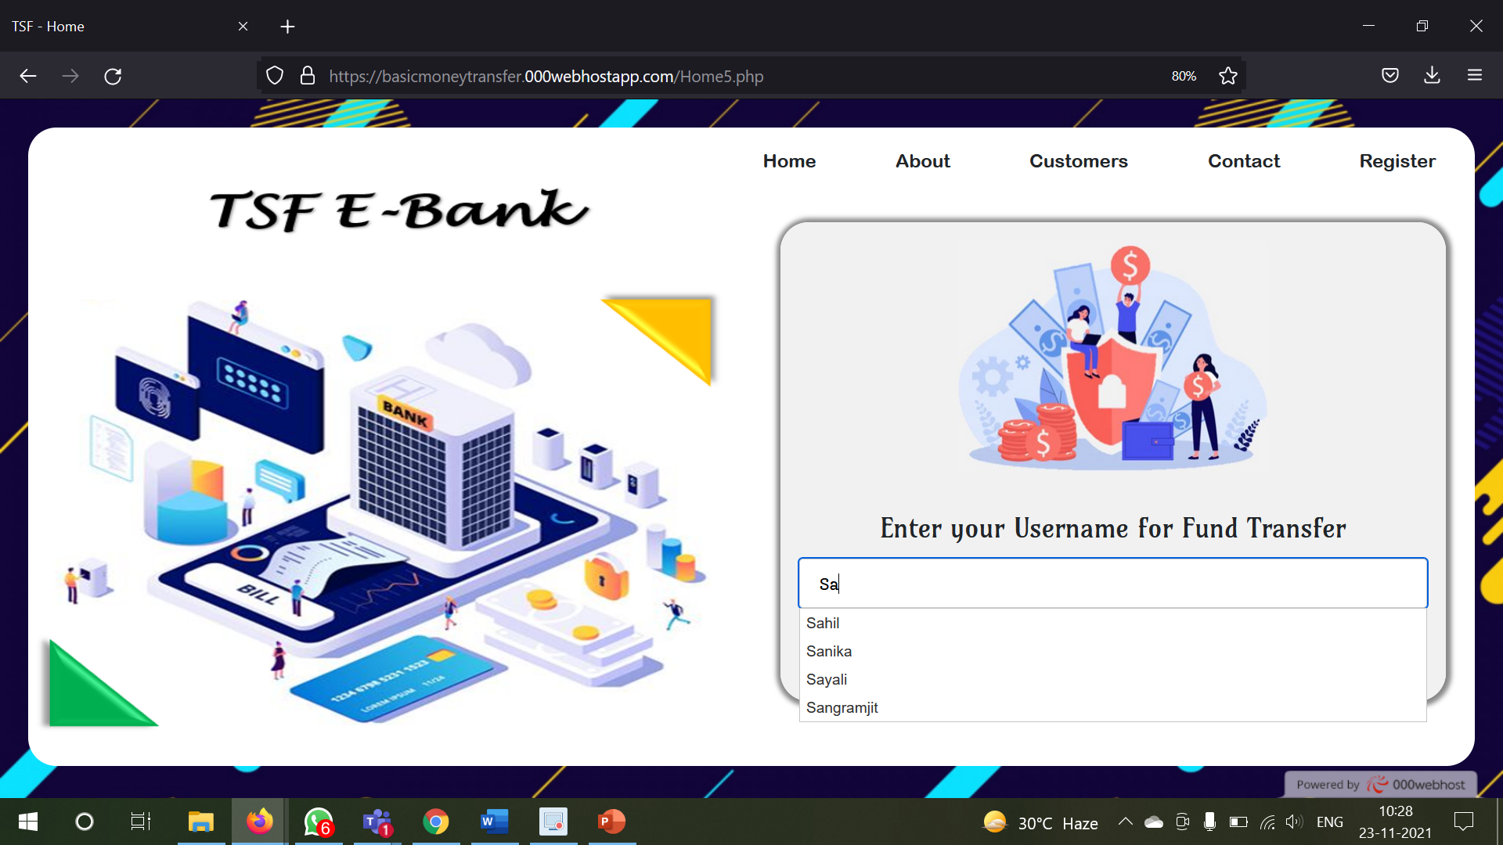

But if the manager tries to type a username which does not exist then the portal throws a proper error message

The above which I mentioned is one of the ways to enter into the sender's account

There is one customer option in the top menu bar of the homepage where if the manager clicks it another division block appears on the same webpage without changing the web page

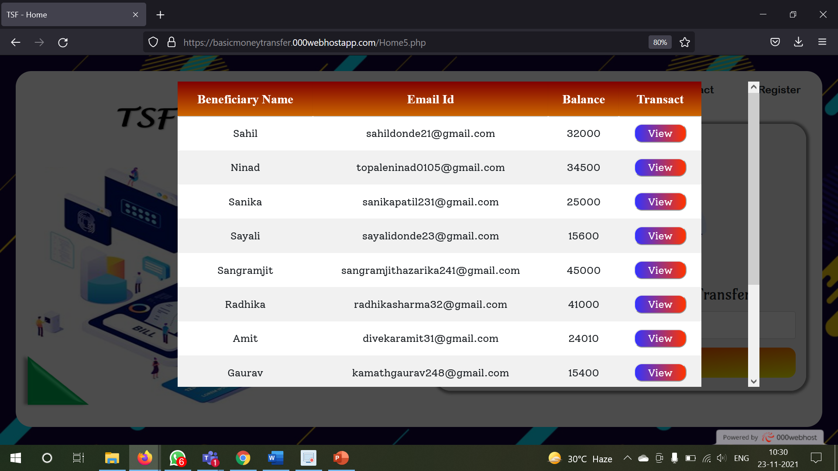

In this division the manager can view all the list of registered users in our portal where there is a transfer money button corresponding to each of the user

So, the manager can identify the sender's name from that list and can click on transfer money but then corresponding to the sender row and can enter into the sender's account.

Once the manager enters the senders account, then a PHP session variable is initialized of senders’ name.

**Transaction**

Now when the manager enters into the sender's account this is the second web page of my project

Let’s say if manager enters with the sender as ‘Sahil’

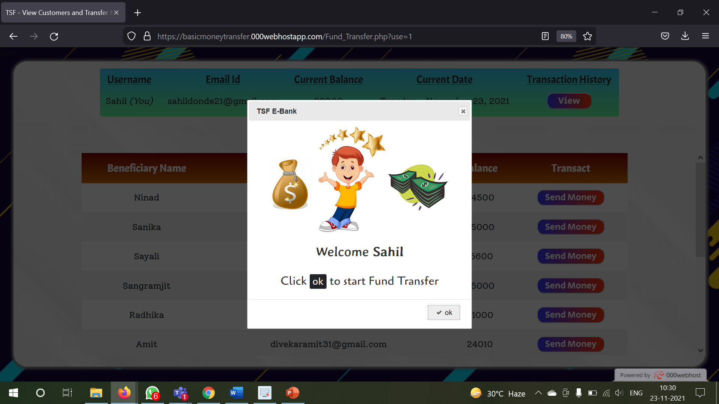

On the top of this webpage the manager can view all the details of the sender

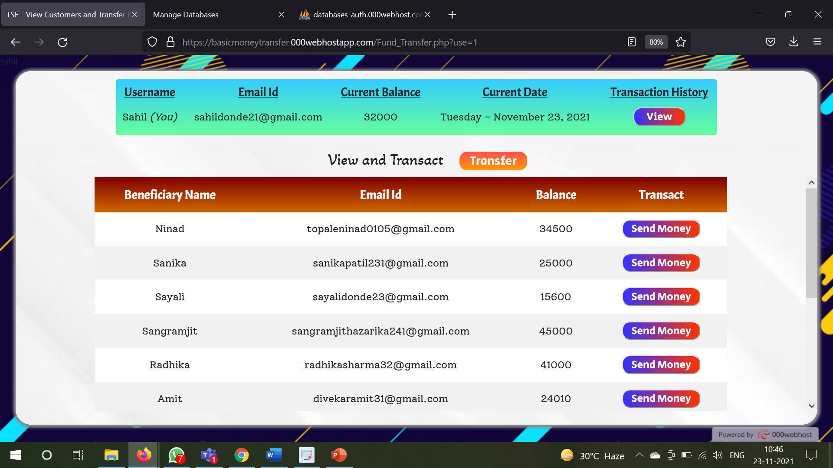

Then in the middle there is a view and transact button where if the manager clicks then a division block comes into the centre of the webpage without changing the webpage

This division is a form which contains the sender input field which is already filled since the manager entered into the sender’s account and the PHP session variable is already initialized, so it is taken from there.

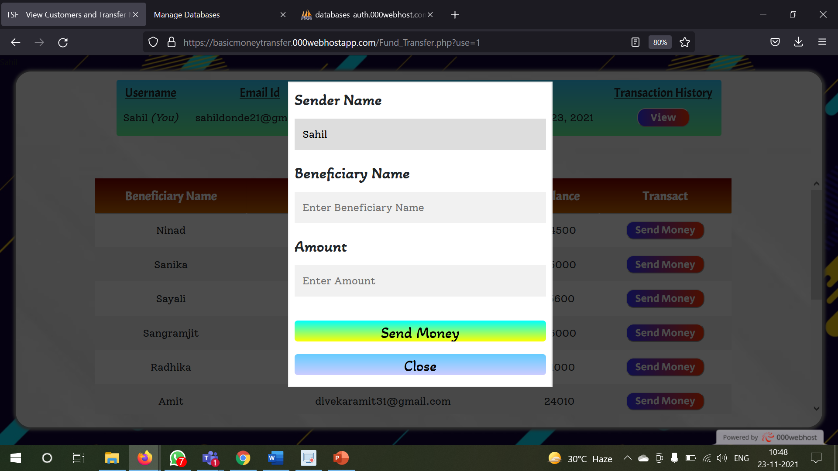

Then the manager enters the beneficiary’s name and the amount to be transferred

Now while entering the beneficiary’s name, you are also due to the auto complete feature, a dropdown appears where all the registered user names are present

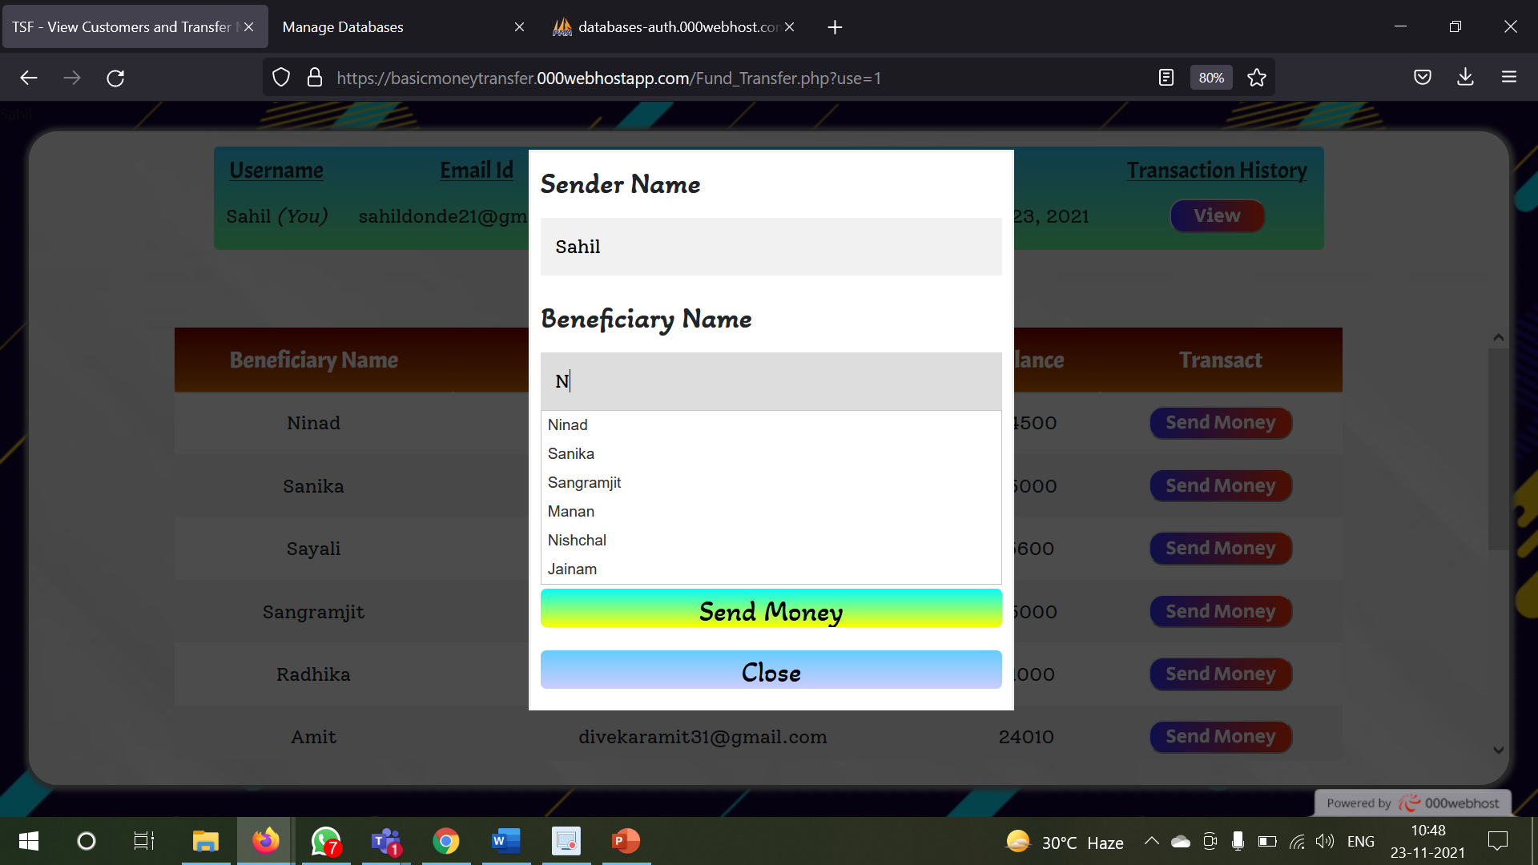

Actually, a function runs when a key is pressed on input box where all the usernames which are registered are been fetched from Users database and with the help of PHP, I stored all the names in a PHP array and converted it into a JavaScript array and passed it to the Autocomplete widget of the jQuery. And in the drop down we are able to see the list of elements in that array.

The manager just selects one of the usernames which is being mentioned in the cheque slip and clicks on transfer amount

If the transferred amount is greater than the senders balance then an error pop up is thrown

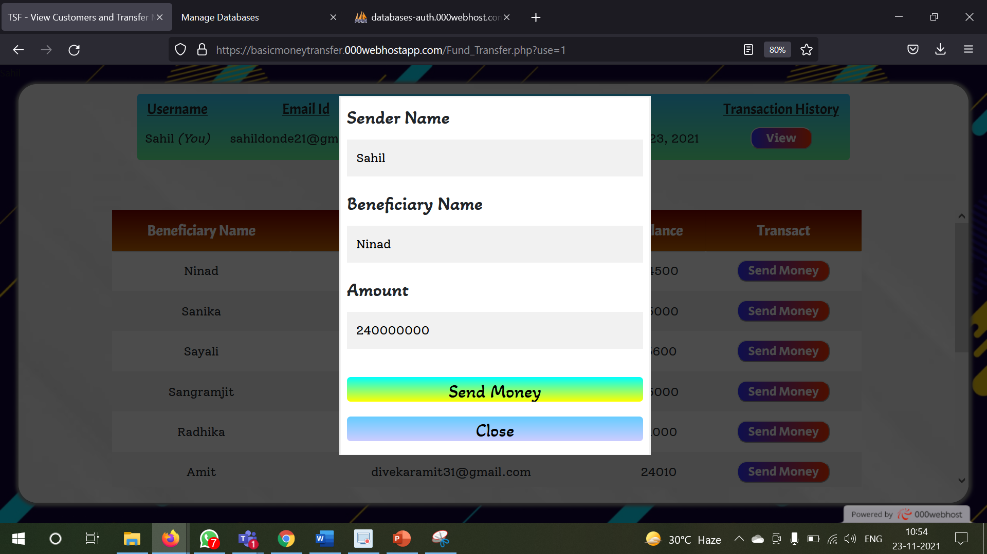

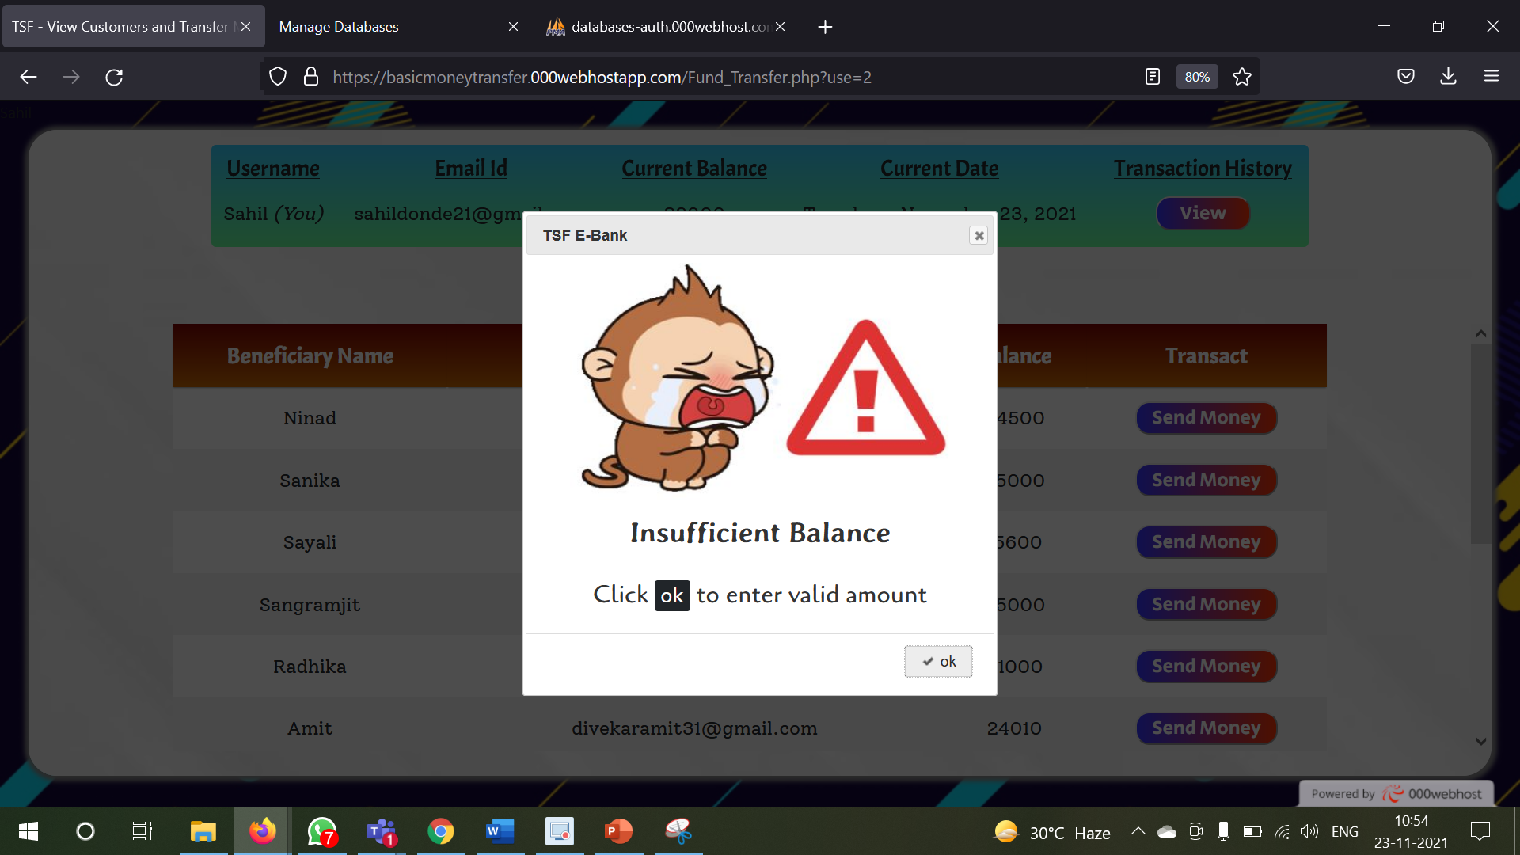

So, re-entering again the amount within the balance

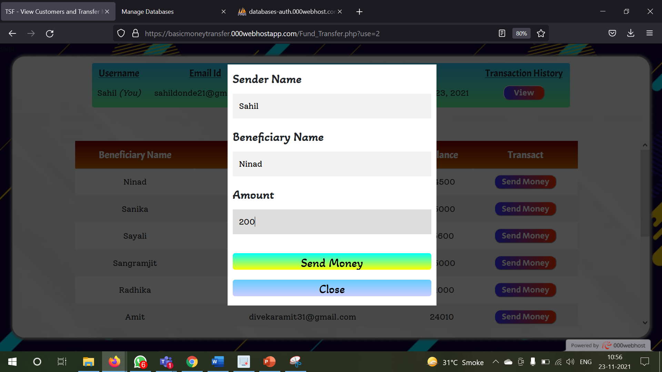

Successful Transaction

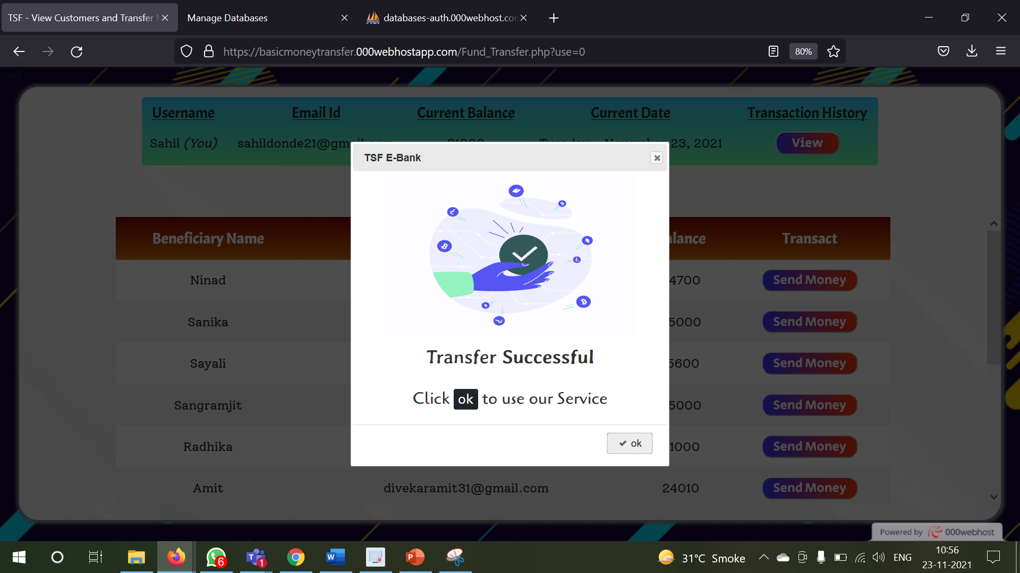

Before Transaction: -

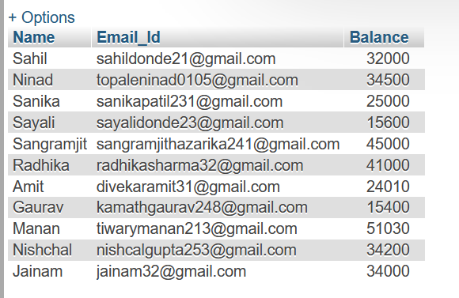

After Transaction (Database Updated): -

200 Rs added/credit to Ninad account and 200 Rs subtracted/debited from Sahil account

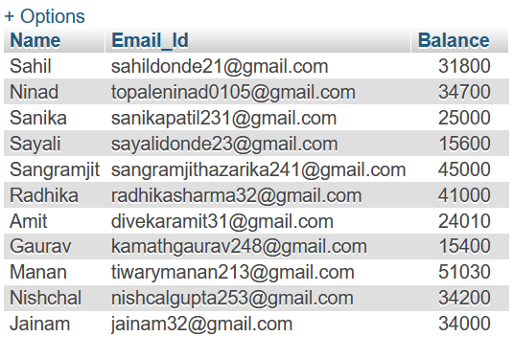

Transaction table Update: -



Now in the database of the users the money is being updated in both the accounts

This was one of the ways to transfer money

Now in the middle of the webpage there consists another division block which contains the list of all the registered users in our portal that is those users which have their rows in MySQL database

This division block contains HTML table which has all the rows corresponding to each of the registered users

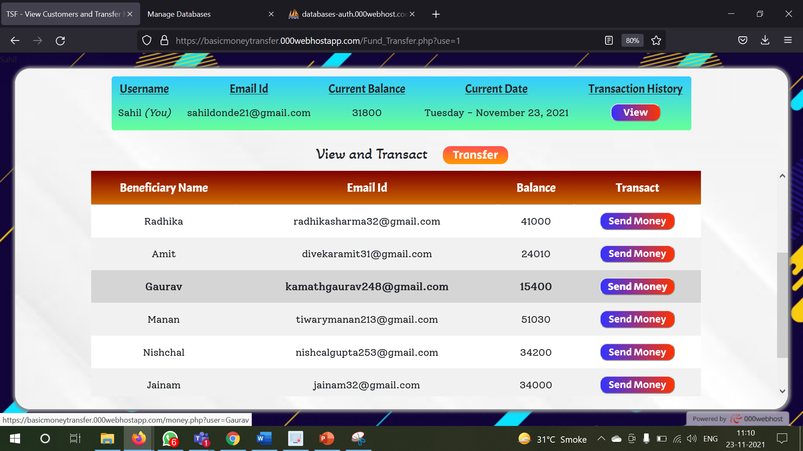

Corresponding to each of the users there is a transact button wherein if the manager clicks it the manager is redirected to another page where the manager can view the Senders information and the beneficiary’s information to which is the money needs to be credited

In this page due to the PHP session variables a session of the beneficiary’s name has been started and the session of the sender has been started during the initial entry of the manager into the sender's account

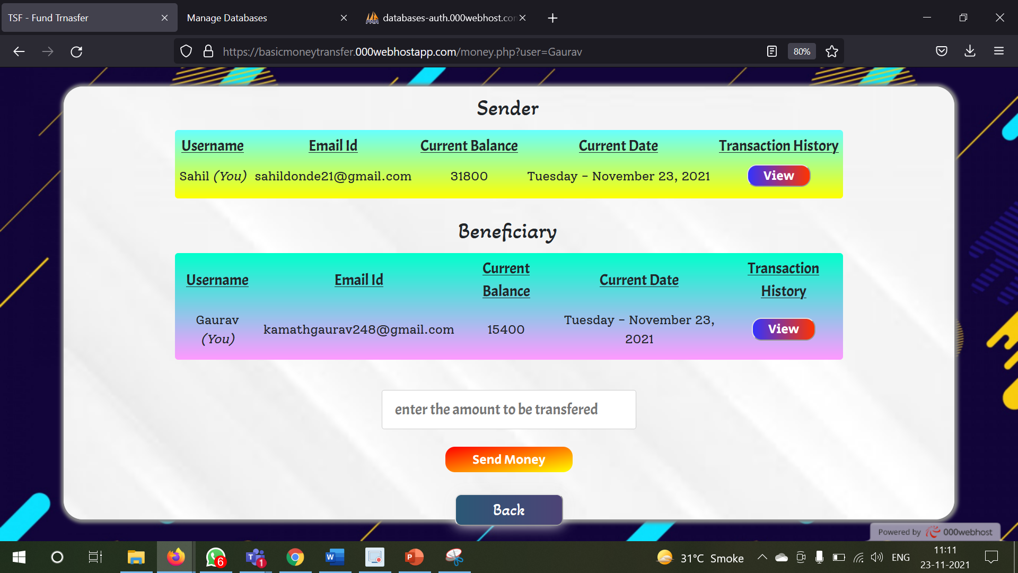

So here we have both sender's name and the beneficiaries name and their respective session variables

The manager just needs to enter the transacted amount into the amount input box

If the amount entered is more than sender’s balance then the system will give a proper error and the manager needs to enter the amount again which must be within the sender's balance

When the manager clicks on transfer button two tables within the MySQL database are being affected

One is the user table where the sender’s account is debited there the money is being reduced and the beneficiaries account where the money is being credited there the money is being added by the transacted amount

The other is the transaction table where a row is being added which includes the sender’s username beneficiary’s username amount that is being transferred and the date-time which tells when did the transaction occurred

The manager has the option to view the transaction history of the sender and the beneficiary both

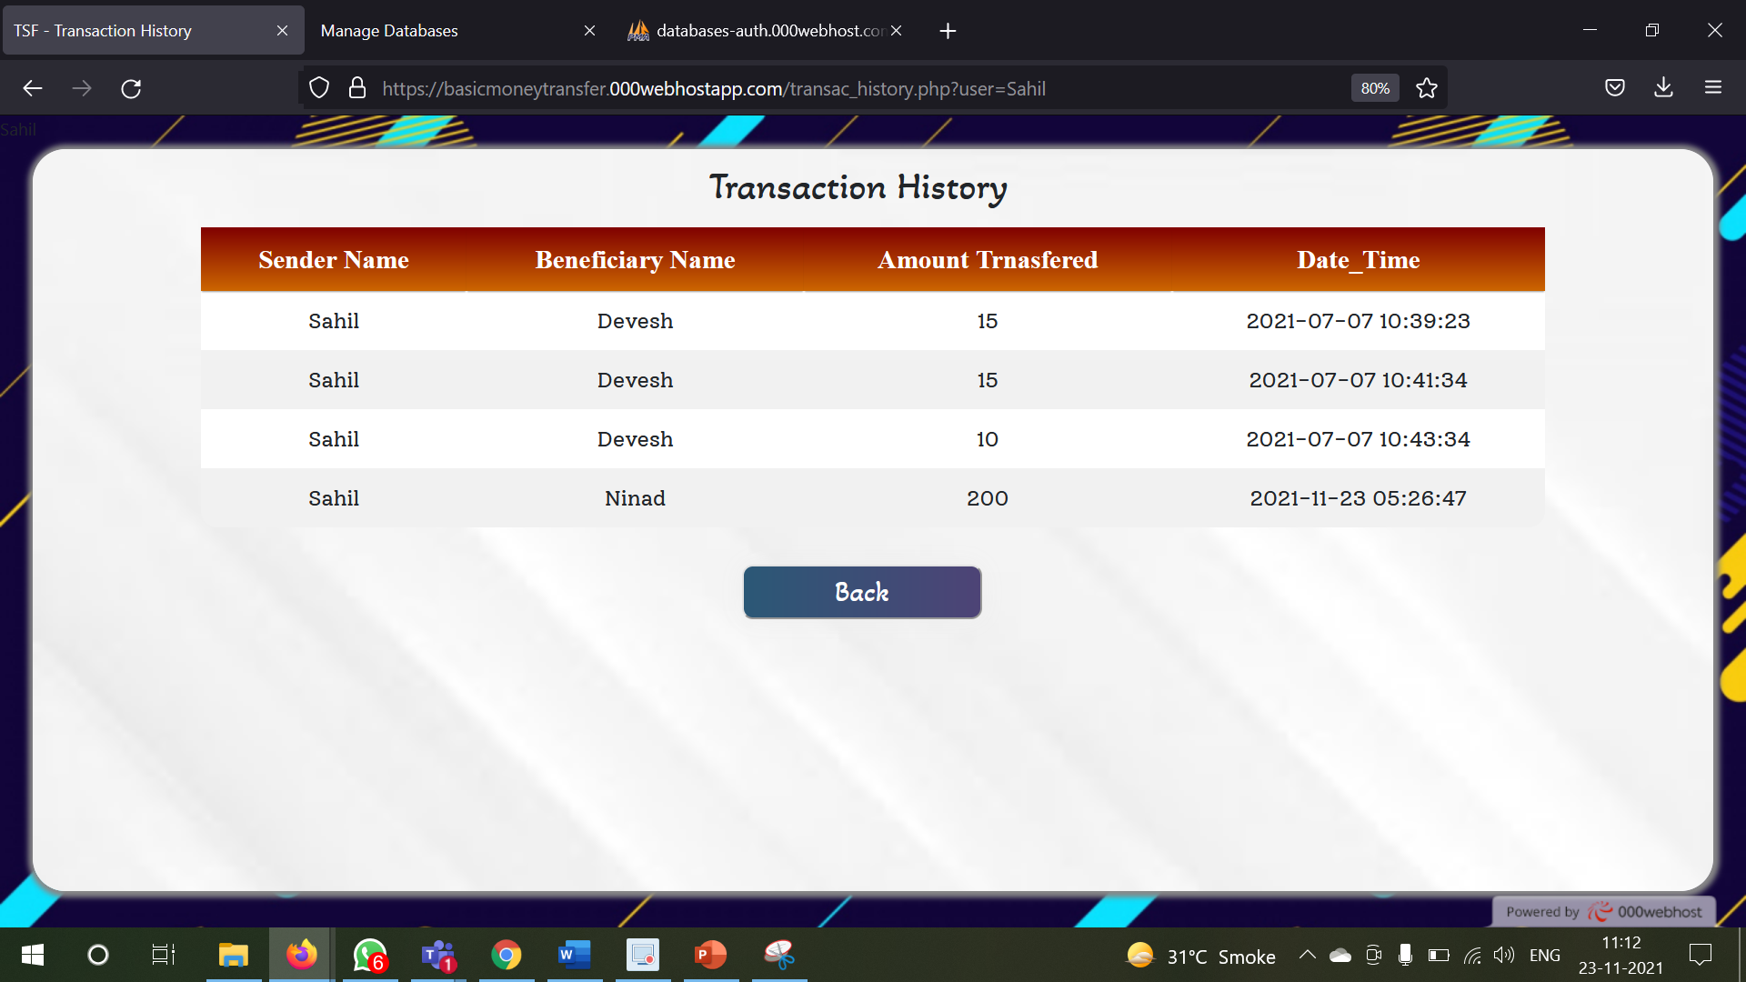

On the home page, in the Contact section, the creator of the web application information given, i.e., my contacts

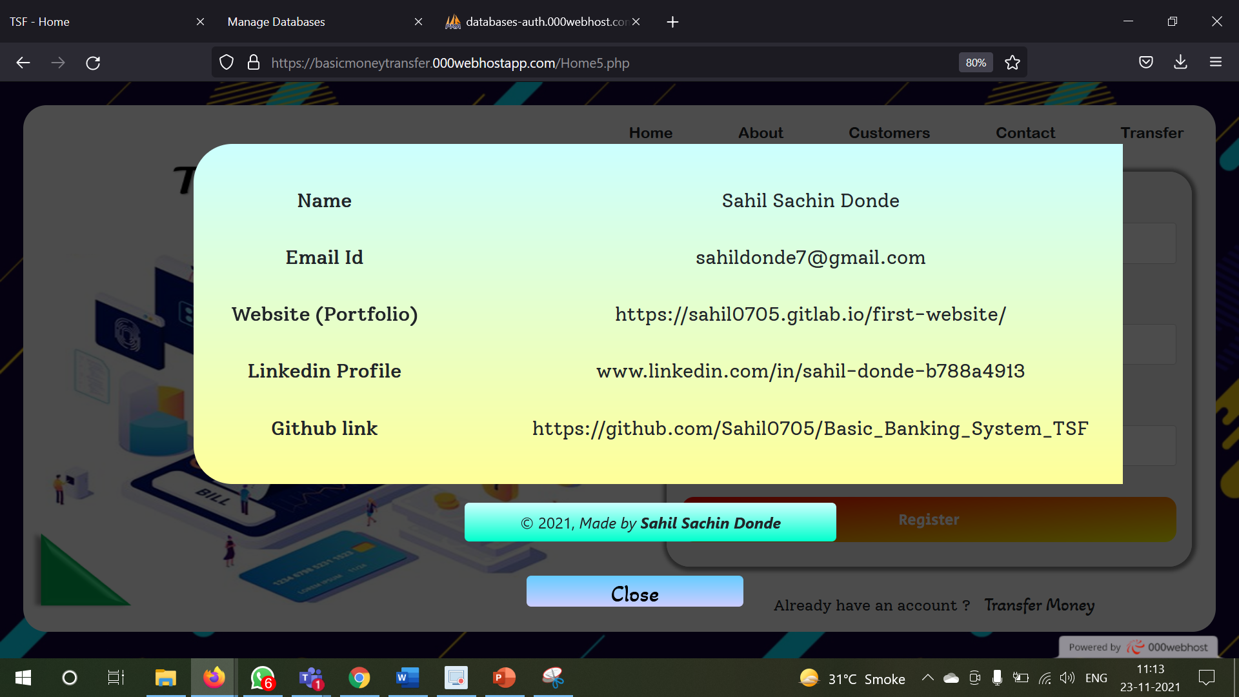

**UI Design: -**

For the UI design I have tried to make the entire web application as appealing as possible

I have given different types of gradient colors to many division blocks and lots of buttons in the web application

I have tried to use the division block of the JavaScript as much as possible in coherence with the JavaScript events and the show or hide attributes of CSS in order to reduce the total number of web pages

If I didn't use the division blocks in such a way then there would have been in all 10 to 11 web pages but now that I have used these many division blocks with the combination of JavaScript events, I have reduced the total number of webpages to 4

This way the loading time of different webpages would reduce

I have given various colourful vector images and various GIF to make the web application more interactive

For all the tables which contains the list of total users which are registered in the portal I have given a separate scrollbar for that table only

For example, if the size of the table exceeds the total height of the webpage, then naturally, we need to scroll the entire web page to see the other users but instead of making the whole webpage scroll what I have done is to just scroll that division which contains that table

This way I have avoided the scrolling of the entire web page and preserved the principle of the web page UI design

For the fonts I have tried to use various unique font families, font sizes and font colours

I have given various hover effects on various HTML elements on all of the 4 web pages

I have used 2 main jQuery widgets that are autocomplete widget and the message box widget due to which I have enhance the JavaScript and CSS functionality by making it more appealing

For all the pop ups which are required to give any success message or any error message to the user or the manager I have make used of the message box widget of the jQuery library

So, whenever the pop ups shopping displayed, I have made the background part as transparent black so as to ensure that the pop-up feels like it is far above the main background page - like 3D effect

For all of the 4 web pages I have one common background image and on top of that I have fun revision blog and, on that block, all the elements are placed so as to look like in 3D style

**Testing and Validations: -**

I have given a lot of validations in my website project

Starting from the registration where I discussed earlier that if any particular user is already existing with a certain username, then another user with the same username cannot get registered in my web portal

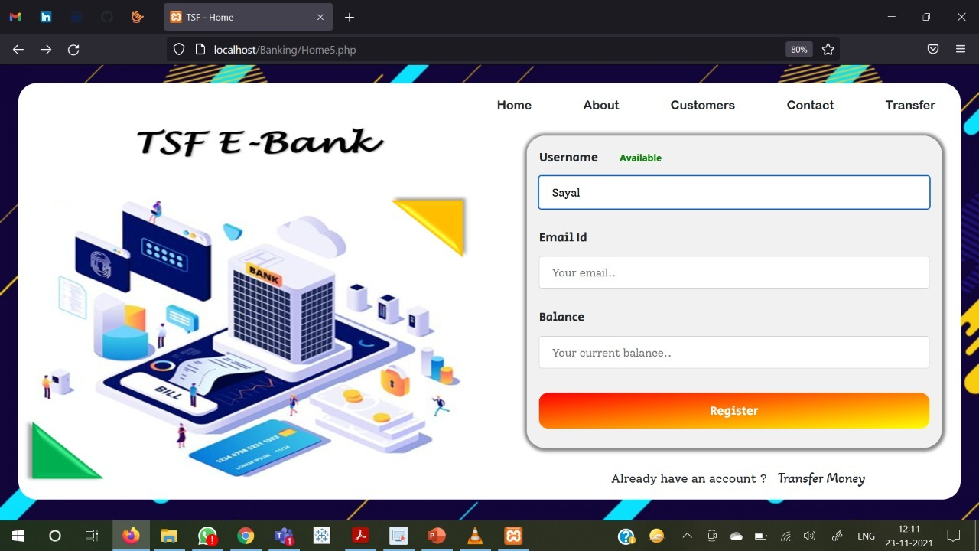

Now as the manager types in the user’s name and the user input field a JavaScript function advanced which with the help of PHP it checks with the MySQL database whether that particular entered username exist or not and accordingly results where it shows available or unavailable as per the results obtained from database

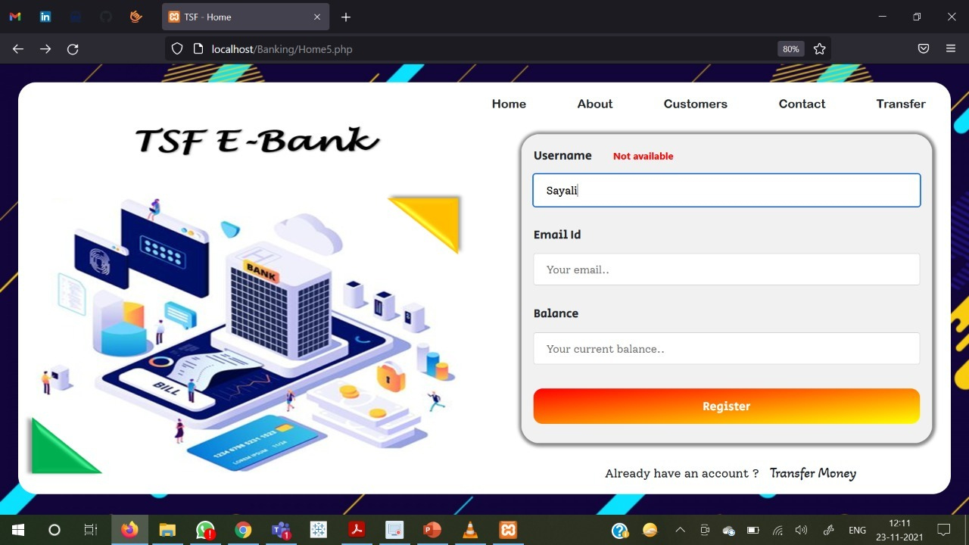

Even to the username is unavailable that is the username already exists in the database then also if a particular user tries to register with that same user name, then a jQuery popup message box is being popped up in front of the users saying that the username already exists and the user needs to enter the details again

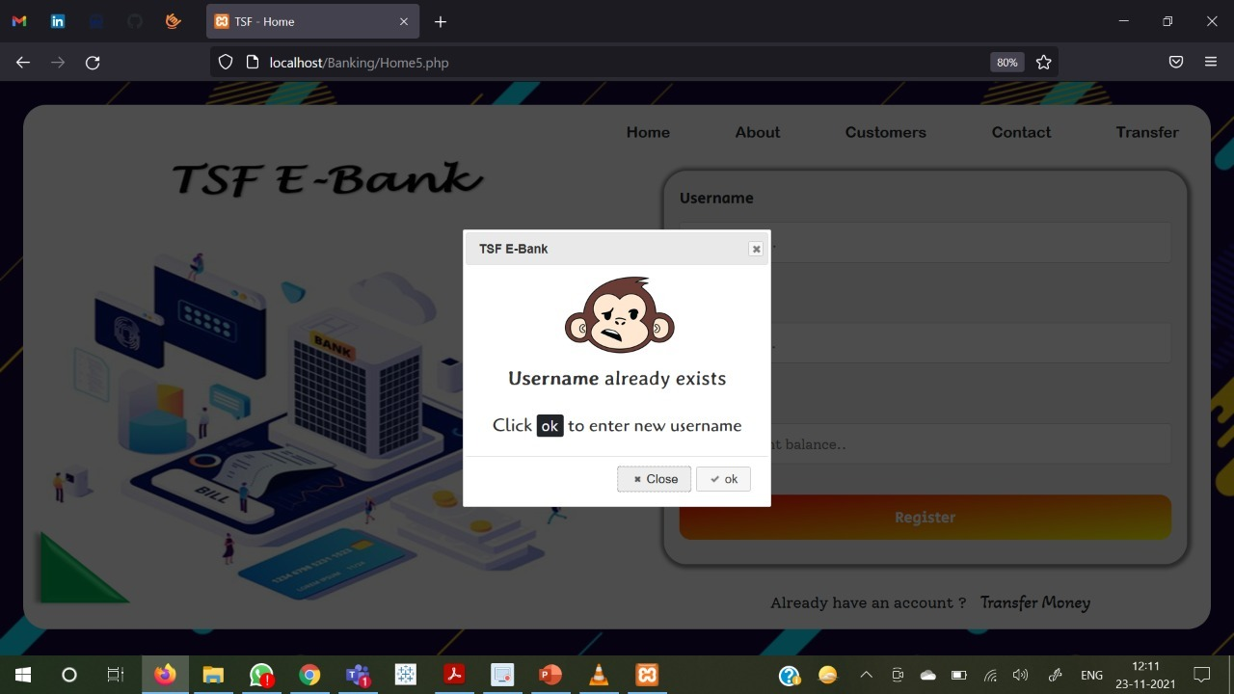

I have also given for JavaScript regex validation for the email field

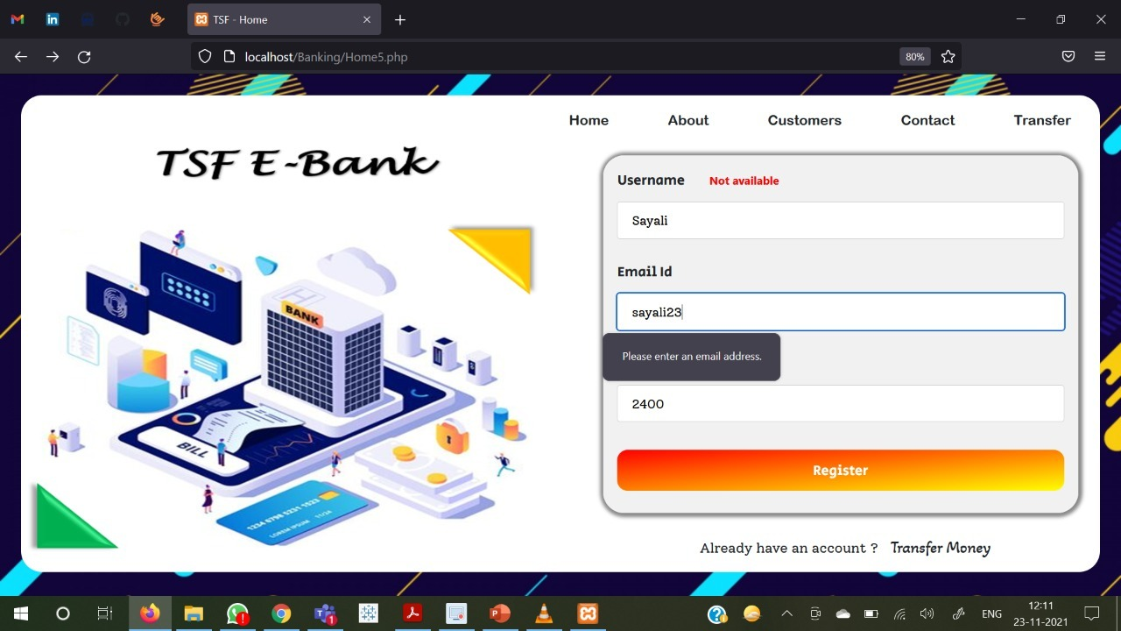

Now when the manager goes inside into the sender's account then you when he clicks on transact option then he enters the beneficiary’s name and the amount to be transacted

If the money to be transacted is greater than the standard account then the web portal throws a proper jQuery message box error stating insufficient balance and if transacted amount is less than the balance when a success message box is being popped out to the user

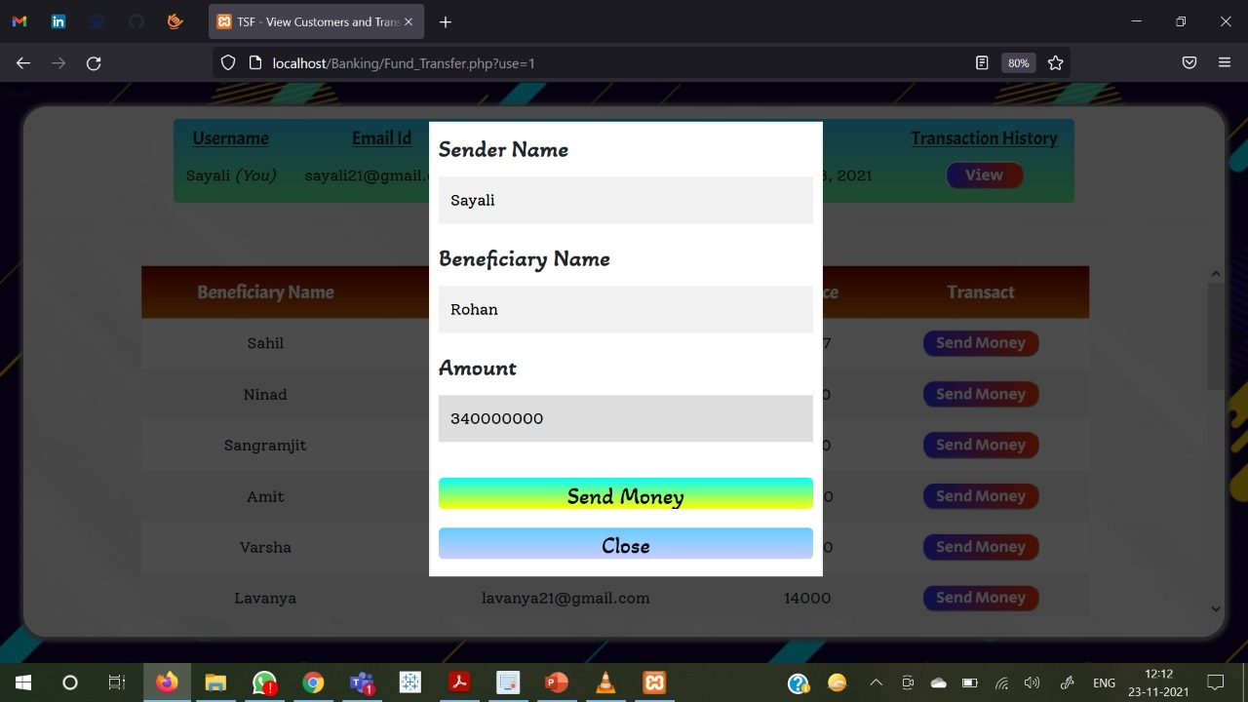

Whenever there is any error from the user where the system has detected by giving a proper error message then the database is not being affected

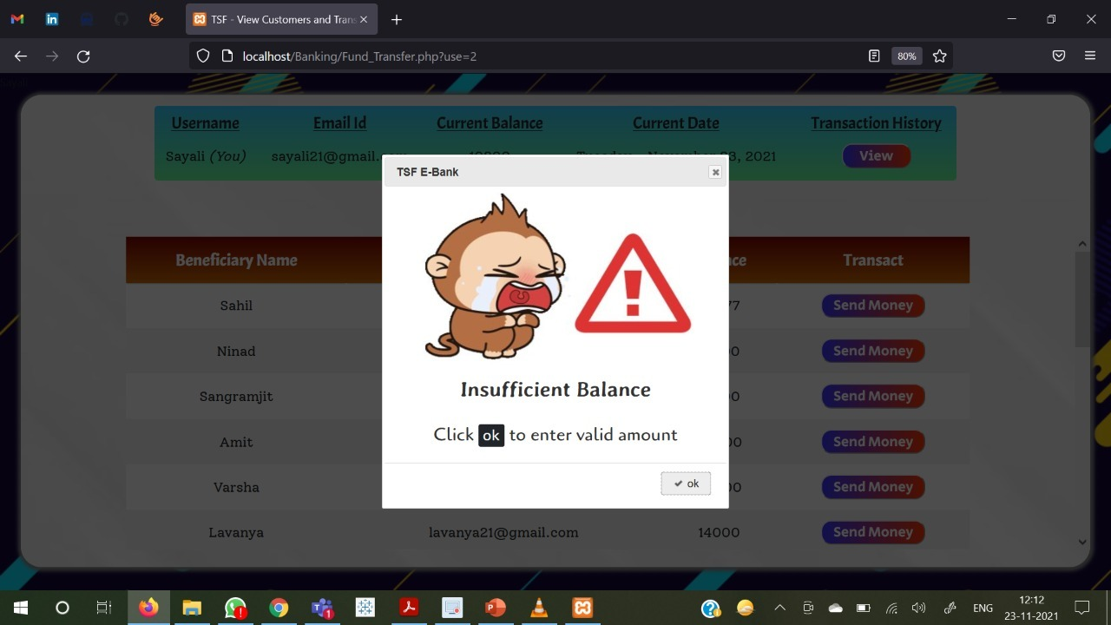

**Future Scope: -**

For the future scope what can I do is that when the manager registers of particular user into our portal I can implement an OTP system where when the manager tries to register that user then OTP would be sent to that user and only when the manager enters the OTP, then only the account is being created



Also, there could be a secret key for a particular Bank and while the manager types in the sender’s user name and when he tries to enter into the sender’s account, he needs to enter that secret key or password to enter into the sender’s account



One of the future scope improvements would be that while transferring money from the sender's account before the actual transaction takes place, an OTP will be send to the sender and only when the manager enters the OTP then only the transaction takes place